Food Security and Global Politics: New Avenues of Research
18-19:30, April 20th
John Cabot University, Rome
Aula Magna Martini (Franco Pavoncello Campus)
Lungotevere Raffaello Sanzio 11

Workshop Description
The politics of food security and sustainable food systems has been severely challenged by recent global conflicts which have rattled international models of development adopted after the end of the Cold War. Over the last few years, the wars in Ukraine and Gaza, in addition to ongoing crises in Yemen, Sudan, Syria, Afghanistan, Ethiopia and the DRC, among others, have interrupted world food supply chains, created vast humanitarian crises and strained the capacity and will of states and international organizations to help feed those in most need. This workshop explores the new challenges posed by these conflicts to food security from the perspective of emerging scholarship on the theme in international relations and security studies. It asks the following questions:
How are international actors evolving in their responses to new food crises and the uncertainty they have created in the international system? What are the strategic, political and social logics underpinning their behavior? Have recent conflicts and crisis in the international system led to new thinking about sustainable development, food security, and other approaches to development assistance? Vice versa, to what extent has the new fragility of food supplies impacted long-run state thinking about sovereignty and international cooperation? Have recent conflicts impacting food systems generated alternative conceptions of food sovereignty or developmental sustainability or visions of international order altogether?

Institutional Welcome:
Nicholas Startin (Dean of Academic Affairs, John Cabot University)
Antonio Tedesco (Deputy Director, Policy Planning Unit, Italian Ministry of Foreign Affairs)

Chair: Michael Driessen (John Cabot University)
“Post-liberal Humanitarianism and Rethinking Assistance” Ruth Hanau Santini (Università Napoli l’Orientale)
“Russia, Ukraine and Food Warfare,” Simone Papale (University of Parma)
“The Impact of Economic Sanctions on Food Security: A Global Review,” Sara Moussavi, (John Cabot University)
“Social Assistance or Capital Protection? Accumulation by (un)certainty in the Era of Global Food Crises,” Matteo Caravani (Tufts University, Feinstein International Centre (FIC))

Discussants: Delaney Simon (International Crisis Group)

This event is sponsored by the MA program in International Affairs at John Cabot University in collaboration with the Inter-University Research Center on the International Politics of Food Security (CIPolFoodS) hosted by the University of Pavia and the “Italy and the International Politics of Food Security” (ITALIM) research project at the University of Naples “L’Orientale” through the support of the Italian Ministry of Foreign Affairs and International Cooperation through the Unit for Analysis, Policy Planning and Historical Documentation.


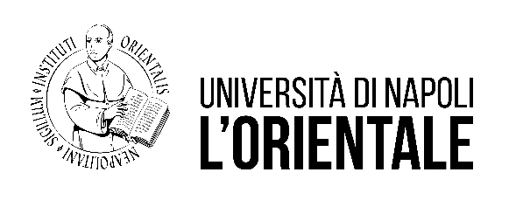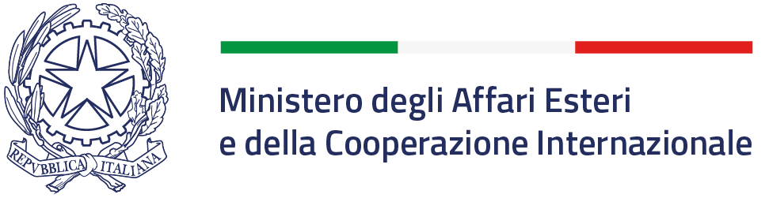

This (project/workshop/volume/article etc.) is realized with the support of the Unit for Analysis, Policy Planning, and Historical Documentation - Directorate General for Political Affairs and International Security of the Italian Ministry of Foreign Affairs and International Cooperation, in accordance with Article 23 ‒ bis of the Decree of the President of the Italian Republic 18/1967.
The views expressed in this report are solely those of the authors and do not necessarily reflect the views of the Ministry of Foreign Affairs and International Cooperation.
The opinions expressed during the conference are those of the authors and do not necessarily represent the positions of the Ministry of Foreign Affairs and International Cooperation.

